How to use MENA (Molecular Ecology Network Analysis pipeline) of Zhou et al., (2011)

1. Go to Jizhong Zhou's lab page & click on data analysis pipelines:

http://www.ou.edu/content/ieg/tools/data-analysis-pipeline.html

1. On page find section on Molecular Ecology Network analysis.

At the end of paragraph it will say “Request access to this pipeline HERE.”

1. Click where it says here and enter your details in page that follows. Should be granted immediate access and taken to page:

<http://129.15.40.240/MENA/main.cgi>

1. Upload your files by going to page 'upload your dataset'. Find file and upload.

* If you are getting an error, likely it means your file is not formatted how MENA would like. See example it gives.
* (see 'MENA formatted shared files' in 'Plotting mothur data' folder of Github if you are having trouble formatting mothur shared files for this.)

1. This will take you to a page with a moving blue strip showing it's processing.
2. Click on 'Main' again (even if blue bar is still moving) and then ‘Search datasets’ you'll see process of upload. – it’ll say ‘done’ under the column ‘Status’ when completed

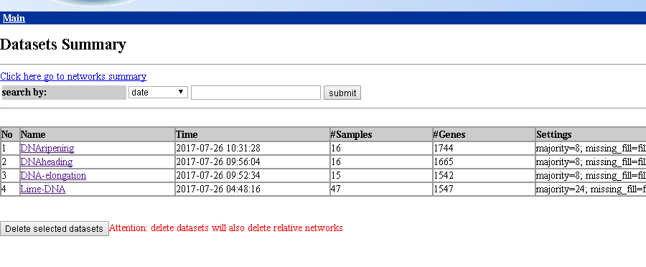

1. Once it’s done, choose ‘Construct network.’

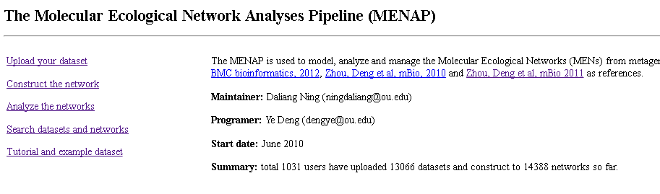

1. Now you have to choose the settings of the construction. You can leave defaults initially, but it’s suggested you read around paper using this tool and see what they do & why. The thing most like to change (esp if you need to reduce the size of your network) is the ‘Majority’ setting.
2. The setting page will look like image below. Make any changes you want then click ‘submit’ (bottom left).

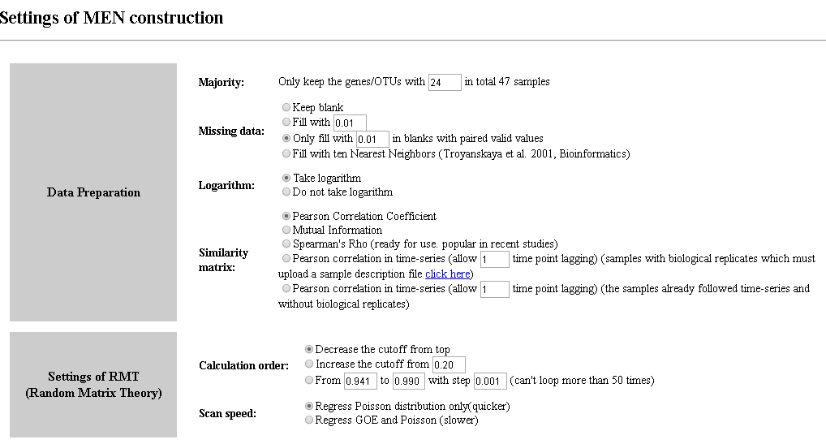

1. After clicking submit, the following page will appear:

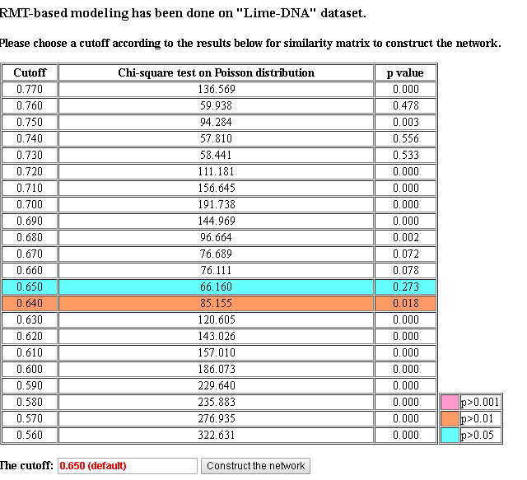

1. Decide if you want to change default cut-off, eg because of bad p values or if comparing >1 network, some paper seem to then choose same cut-off for all. Click ‘construct the network’. And the following information will appear (copy and paste to text file for records):

The threshold for Pearson is 0.650  
Total Nodes : 321  
Total Links : 423  
Average Connectivity : 2.63551401869159  
Average length : 6.563  
R square of power-law: 0.892

1. Click on ‘main’ then ‘analyse networks’ and the following page should open:

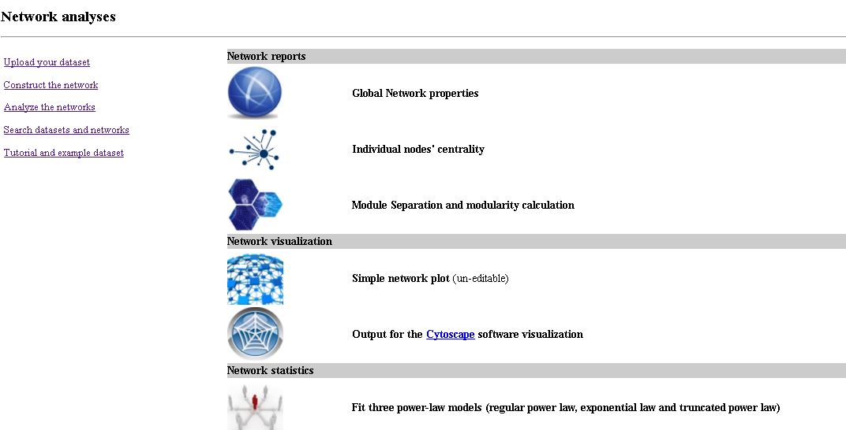

1. Each time you click on one of these you’ll have to specify which of your datasets you want the information for (as you can have more than one OTU table uploaded).
2. If you go on ‘global network properties’ you can find all the settings used for the network construction, including (down the bottom) all the Pearson correlations for your OTUs. Save this info for reference.
3. You can also get info about node centrality on relevant link
4. Next, choose Module Separation and modularity calculation (you need to do this before getting output for cytoscape).
5. On this page, there are four options to choose from in order to define the modules within the network. After choosing one and clicking submit, a page will appear on which an ‘M’ value will be given, as shown below.

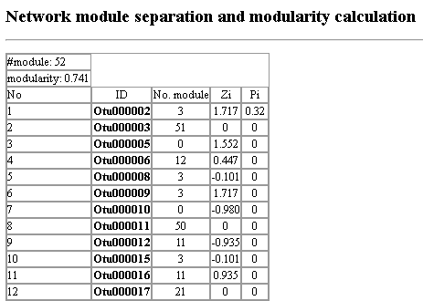

1. As done in Deng et al., 2012, it is probably best to try each of these modulation methods, and see which one gives you the higher M value as this one will be “more effective in separating the complex networks into submodules.”
2. You can have quick squiz at your network in the ‘Basic network’ section, but probably it ‘ll be a little ugly, so go to “output for Cytoscape visualisation”, it’ll ask which module-separation method to use – choose whichever gave best M value and submit
3. Right click and ‘save link as’ to download each of the three files given.